- Brief Country Profile

Poland, a vibrant middle-sized country, covers an area of 312,679 km², making it slightly larger than Italy and slightly smaller than the US state of New Mexico. With a population of about 38 million and GNI per capita of nearly US$12,400 (2016), Poland has the largest economy in Central Europe.

Poland is bordered by Germany in the west, the Czech Republic in the south west, Slovakia in south, Ukraine in south east, Belarus in east and Lithuania and Russia in the north east. The country shares maritime borders with Denmark and Sweden. Poland is an almost unbroken plain reaching from the Baltic Sea in the north, to the Carpathian Mountains in the south. Within that plain, terrain variations run in bands east to west. The Baltic coast has two natural harbors, the larger one in the Gdańsk-Gdynia region, and a smaller one near Szczecin in the far northwest. The northeastern region also known as Masurian Lake District with more than 2,000 lakes.

The official language of Poland is Polish. The largest city is the capital city of Warsaw.

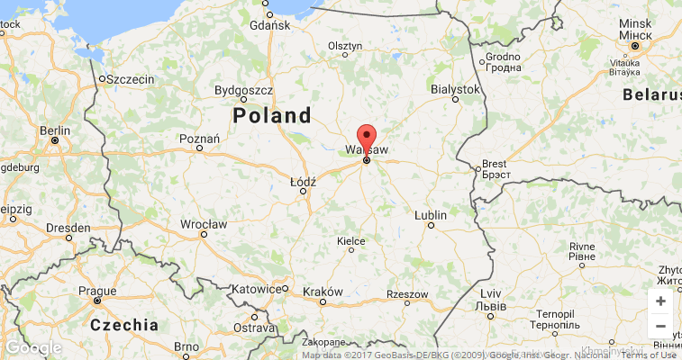

In Poland the climate is temperate with cold, cloudy, moderately severe winters with frequent precipitation, as well as mild summers with frequent showers and thundershowers.

- Forestry and Forest

- Forest area
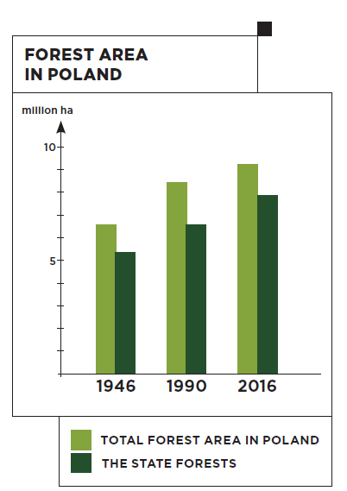
Poland takes the leading position in Europe as far as the forest area is concerned. Poland is the fourth most forested country in Europe. According to measurement standard adopted by the international assessment which takes into account also the lands associated with forestry, the forest area in Poland is 9420 thousand ha, as of 31 December 2015, and is close in size to the forest area of Ukraine and Italy.

The forests grow on 9.2 million hectares (9,4 mln ha with land related to forest management) which is 29.5% of the territory of Poland. The vast majority of this area are forests owned by the state, out of which almost 7.6 million hectares are under the State Forests (SF) Holding management.

Under SF management
7.6 mln ha
In Poland 80.8% of forests are public
Forest area in Poland
9.2 mln ha

- Forest coverage and its change

There are more and more forests in Poland. The forest cover increased from 21% in the year 1945 to 29.5% at present. From 1995 to 2014 the forest area enlarged by 504 thousand hectares. The basis for the afforestation works in Poland is the National Programme for the Augmentation of Forest Cover with the assumption to increase the forest cover up to 30% in 2020 and up to 33% in 2050. Poland’s forests are rich in flora, fauna and fungi; 65% of species occurring in Poland live there.
Forest cover:
1945 – 21%
2015 – 29,5%

Forest cover in Poland by voivodeship, 2015.

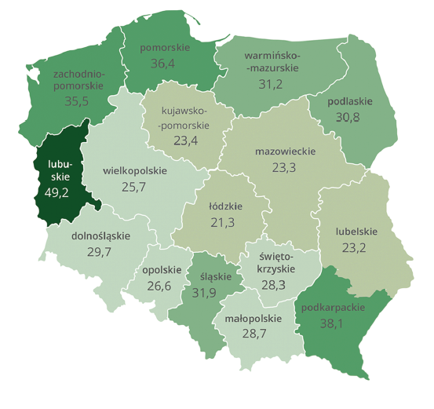
Source: Central Statistical Office, Forestry, 2016.

There is a wide variation of forest cover among voivodeships. According to the chart above, Lubuskie voivodeship has the highest forest cover and Łódzkie the lowest. However, there is no voivodeship with under 20% forest cover in Poland.

- Forest classification

In Poland the large majority of forests are natural with plantations covering an area of around 60 000 ha. All forests in Poland are managed sustainably. The idea of sustainable forest management is based on the premise that forest ecosystems can fulfil a variety of functions, from economic to environmental.
The share of protective forests in all ownership categories in the total forest area in Poland currently has reached 41.2%, and including the area of nature reserves – 42.3%. The State Forests have a legal obligation to act according to the principles of sustainable forest management which is aimed at preserving the sustainability of forests, their continuous multifunctional use, and the augmentation of forests resources. The chart below presents the share of protective forests in the State Forests.

Source: Directorate General State Forests.

- Forestry structure

The forests in Poland grow on the poorest soils, mostly as a result of developing farming in the previous centuries. This affects also the spatial distribution of forest site types in Poland.
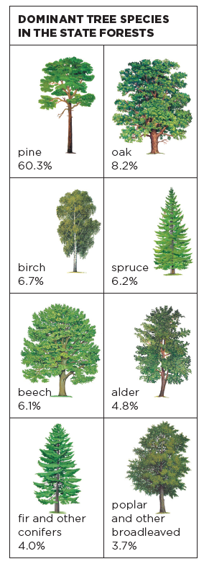
In the lowland and upland areas the most frequent species is pine. It overgrows 64.3% of the forests area in the State Forests Holding and 57.7 % of private and commune-owned forests. In the mountains spruce is predominant (western part) and spruce with beech (eastern part). The domination of pine in the forest stands is the result of the past forest management practice. Previously, the monoculture (one-species cultivation) was the forestry’s answer to the expanding industrial needs for timber. Such forests, however, were less resistant to climatic factors and were falling victim to pests more easily.
In Polish forests, the share of other (mostly broadleaved) tree species grows systematically. The foresters do not practice monoculture any more, instead they adjust the species composition of stands to that occurring naturally in a particular area. Therefore the area of broadleaved stands in the State Forests increased from 13% to more than 28.2% in the years 1945-2014. The more plentiful tree species are oak, ash, maple, sycamore, elm but also birch, beech, alder, poplar, hornbeam, aspen, linden and willow.
The forest stands aged from 40 to 80 years occur most frequently in Poland, and the average age of forest stands is 60. There are more and more big 80-year-old trees. Their area has increased from 0.9 million hectares to almost 1.85 million hectares since the end of the World War II. Stands representing age classes III and IV prevail in the forest age structure and cover 25.5% and 19.1% of the forest area, respectively.
The geographical distribution of habitats is, to a great extent, reflected in the spatial structure of dominant tree species. Apart from the mountain regions where spruce (west) and spruce and beech (east) are the main species in stand composition, and a few other locations where stands have diversified species structure, in most of the country stands with pine prevail as the dominant species.
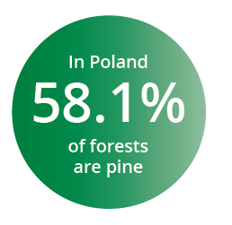
In terms of forest area, coniferous species dominate in Polish forests, accounting for 68.7 % of the total forest area. Poland offers optimal climatic and site conditions for pine within its Euro-Asiatic natural range, which resulted in development of a number of important ecotypes (e.g. the Taborska pine or the Augustowska pine). Pine accounts for 58.1 % of the area of forests in all ownership categories, for 63 % in the State Forests and for 55.4 % in the privately-owned forests. Apart from mountain regions, where the share of spruce, fir and beech in the stands species composition is larger, in most of the country pine is the dominant species in the majority of stands.

Since 1945 forest species structure has undergone significant changes, expressed, inter alia, by increased share of stands for deciduous trees. Considering state forests, where it is possible to trace this phenomenon on the basis of annual updates of forest land area and timber resources, total area of deciduous stands increased from 13 to 31.3% currently. Despite the increase in the surface of deciduous forests, their share is still below potential, arising from the structure of forest habitats.

- Forest stock volume, increment and logging

The main source of information about the volume of timber resources in Poland is the National Forest Inventory. According to the statistics collected in the years 2011-2015, and based on the forest area as it stood at the end of 2014, the timber resources in Poland amounted 2491 mln m3 of gross merchantable timber, of which 1965 million m3 were in the State Forests.
All forests
in Poland
are managed sustainably
According to the results of the National Forest Inventory 2011- 2015, the average volume of growing stock in forests managed by the State Forests was 277 m3/ha.

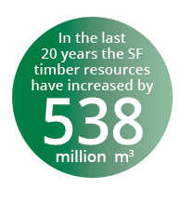
Since 1967, when the first update of timber resources in the State Forests was made, there has been a steady growth in the volume of timber. In the last 20 years, from January 1995 to January 2015, the increment of gross merchantable timber in forests administrated by the State Forests amounted to 1225 million m3. During this period 687 million m3 of merchantable timber was harvested, which means that 538 million m3 of gross merchantable timber, representing 44% of the total increment, remained to augment the volume of standing timber resources. The current annual increment of gross large timber volume, in the last 20 years (1995-2015), as the difference in volume at the end (January 2015) and beginning of the period (January 1995), including harvest and calculated per 1 ha of forest area managed by the State Forest Holding, amounted to 8,8 m3/ha, whereas the current annual increment of gross large timber, calculated in the same manner, for the last five years is 9,1 m3/ha. The intensity of use determined on the basis of information from the past five years amounts to 65% of the current increment.

- Felling operation

- The total volume of timber felled in recent 10 years.

The supply of wood in Poland has increased by 100% in the last 20 years, without any harm to the environment. In 2016 the wood production reached 39.2 million m3.


- Forest Management

Forest economy in the State Forests is based on forest management plans designed for a 10-year period. They are obligatory in each forest district. The forest management plans are prepared by specialist units such as the Bureau of Forest Management and Geodesy (BULiGL). The forest management plans are then approved by the Minister of the Environment, however this is preceded by social consultations on the matter.
The plan is prepared after thorough forest inventory and forest condition assessment. The foresters assess such forest traits as structure, age, species composition, health, soil and site conditions, etc. The activities assumed in the plan for further realization include forest management objectives and specific functions of the forest in the area of a particular forest district.
Sometimes it is also acceptable to establish a plan for a period shorter than 10 years. However, it happens only in justified cases such as great damage or natural disasters.
Contemporary management plans are created with the use of the newest technical achievements. The basic instrument is a forest digital map being a part of the spatial information system (Geographic Information System GIS). The map processes the data collected during field work and presents the results in a graphic form. For years, in forest management there have been applied more and more perfected methods of using aerial and satellite photographs, which complete the results of the fieldwork.
The forest management plan should include:
- Description of both forests and lands scheduled for afforestation,
- Analysis of forest economy in the past period,
- Nature conservation programme,
- Description of tasks concerning timber harvesting, afforestation and renewals, forest tending and protection, hunting management and creating forest infrastructure (buildings, roads).
The forest management plan is carried out on the basis of the instructions which are obligatory in the State Forests.

- Institutions associated with forestry

The State Forests National Forest Holding (SFNFH) (Państwowe Gospodarstwo Leśne Lasy Państwowe) of Poland is the largest organization within the European Union managing public forests. It takes care of over three-fourths of Polish forests (7.4 of 9.4 million hectares) on behalf of the State Treasury. Its main mission is to manage national forests in a way guaranteeing their preservation and augmentation of their resources. The State Forests National Forest Holding is an organizational unit without legal personality. The basic document for the State Forests is the Act on Forests of September 28, 1991. It defines the principles of forest management of the State Forests and in the forests of other ownership types. The structure of the organization is defined by its statute, released by the regulation of the Minister of the Environment in 1994.

Contact: General Directorate of State Forests, ul. Grójecka 127, 02-124 Warszawa, http://www.lasy.gov.pl/


Forest Research Institute (Instytut Badawczy Leśnictwa), in accordance with the statutory objectives, conducts research and development in the field: afforestation and forest regeneration, maintenance, use, and ecology, conservation, genetics and economics and forest policy. The Institute is actively involved in the development, to bodies of state power, legislation and other documents, including those resulting from international conventions and agreements, as well as the National Forest Policy.

Contact: Forest Research Institute, Sękocin Stary, ul. Braci Leśnej nr 3 05-090 Raszyn, http://www.ibles.pl/

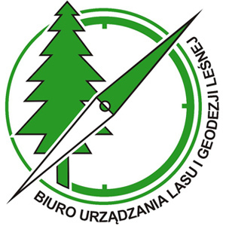
Bureau for Forest Management and Geodesy (Biuro Urządzania Lasu i Geodezji Leśnej) is a planning and expertise company which is one of the pillars of forest management in Poland. They offer a variety of services in the field of forestry, nature conservation and the environment. The Bureau is the main contractor of forest management plans, including habitat inventories and analyses. Forest Act mandated BULiGL to carry out the periodic national forest inventory, updating of forest resource assessment, running data bank on forest resources and forest condition in Poland. They also perform the tasks of environmental monitoring, preparing protection plans for national parks and nature reserves, inventories of Natura 2000 protection areas and other studies related to nature conservation and environmental protection. They Bureau develops geodetic documentation, phytosociological and also in the field of forest engineering.
Contact: Bureau for Forest Management and Geodesy, Sękocin Stary, ul. Leśników 21 05-090 Raszyn, http://www.buligl.pl/

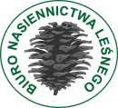
Forest Seed Agency (Biuro Nasiennictwa Leśnego), keeps a register of forestry material and certificates of the genetic origin of material. It also gives permits for the transport of forestry genetic material for non-EU member countries.

Contact: Forest Seed Office Agency, ul. Rakowiecka 30, 02-528 Warszawa, https://www.bnl.gov.pl/


Wood Technology Institute (Instytut Technologii Drewna) is the only scientific-research institution in Poland which deals in a comprehensive manner with theoretical and practical issues of wood processing, its application and creation of new composites based on wood. The Institute’s mission is to conduct research aimed at production of modern materials and improvement of production technologies and processing techniques, which leads to harmonious and sustainable development of the wood industry and to achievement of high international competitiveness of the Polish wood sector. Through implementation of research results in the form of innovative, energy-saving and hygienic materials using both wood raw material and wood waste, which help to improve the quality of life, have positive influence on the environment and health, and increase the share of renewable energy carriers in the national energy balance, the Institute strives to create modern wood sector which meets the requirements of the 21st century society.

Contact: Wood Technology Institute , ul. Winiarska 1, 60-654 Poznan, http://www.itd.poznan.pl/


Faculty of Forestry (Wydział Leśny) is a part of governmental Warsaw University of Life Sciences (Szkoła Główna Gospodarstwa Wiejskiego -SGGW in Polish). It was created 178 years ago to conduct education, research and extension services. Funding from state budget and research projects. Scientific Faculty has full rights and is thus authorized to run doctoral (Ph.D.), post doctoral (Dr.Sc.) and Professors trials.

Contact: Faculty of Forestry, Warsaw University of Life Sciences, ul. Nowoursynowska 159, 02-776 Warszawa, http://wl.sggw.pl/

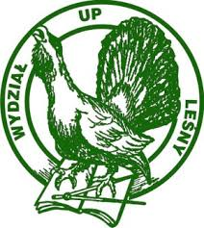
The Faculty of Forestry (Wydział Leśny) was established in 1919 as a part of the University of Life Sciences in Poznań (Uniwersytet Przyrodniczy w Poznaniu), Poland. Our research covers a wide range of scientific problems facing forestry, such as: climate change, biological conditions of forests, silviculture, forest protection, wood production, forestry economics. The basic aim of the Faculty of Forestry is educating future foresters - a professional with a solid knowledge of forests with their ecological mechanisms and features, as well as wood production lines. The main aim of his or her work is the wise management of the forest. This means forest management as a renewable natural resource for the benefit of society, the ecosphere and the wood processing industry.

Contact: Faculty of Forestry, Poznan University of Life Sciences, ul. Wojska Polskiego 28 60-637 Poznań, http://wles.up.poznan.pl/

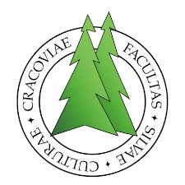
Faculty of Forestry (Wydział Leśny) at the University of Agriculture (Uniwersytet Rolniczy) in Krakow conducts numerous forest research programmes and provides education in forest management and forestry sciences at I, II and III study degrees as well as postgraduate studies. The Faculty Council is authorized to grant degrees of Doctor (PhD) and Habilitated Doctor of Forest Science in the field of forestry and to submit candidates for the title of professor of forest sciences. The Faculty employs 92 members of academic staff including 16 full professors, 17 persons holding DSc. Degrees and 59 persons holding PhD. Degree. The Faculty has an active international agreements and cooperates with numerous universities and research institutes, both Polish and foreign: Austria, Canada, Germany, Italy, Japan, Netherlands, Norway, Slovakia, Spain, Sweden, USA, Finland and other.

Contact: Faculty of Forestry, University of Agriculture, Al. 29 Listopada 46, 31-425 Kraków, http://wl.ur.krakow.pl/

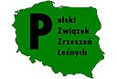
Polish Union of Private Forest Owners (Polski Związek Zrzeszeń Leśnych). The first step to create the POLISH UNION OF PRIVATE FOREST OWNERS was the agreement reached in October 2010, which was signed by representatives of: Ministry of Environment, Ministry of Agriculture and Rural Development, General Directorate of State Forests, National Council of Agricultural Chambers and members of associations representing private forests owners. On 25th of May 2011, the Polish Union of Forestry Associations was registered in the National Court Register. Its seat is located at the Forest Research Institute in Sękocin Stary at Braci Leśnej 3 Street.

Contact: Polish Union of Private forest owners, ul. Braci Leśnej 3B 05-090 Raszyn, http://pzzl.pl/


Polish Forestry Society (Polskie Towarzystwo Leśne) was established in 1925, however, its beginnings can be traced till 1882. During the 1920’s and 1930’s the Polish Forestry Society has contributed to the development of forestry in an independent State. The second world war had disrupted the Society’s activities, which were then continued from 1946.

Contact: Polish Forestry Society, ul. Bitwy Warszawskiej 1920 r. nr 3 02-362 Warszawa, http://www.ptl.pl/

- Forestry employment

- The number of employees in forestry
About 57 thousand people find employment in Polish forests, among them foresters, wood cutters and those planting and caring for threes. On a national scale this is not a very numerous group, but many more people, about 300 thousand, are employees in related plants and industries such as sawmills, furniture factories, building materials factories and the paper industry.

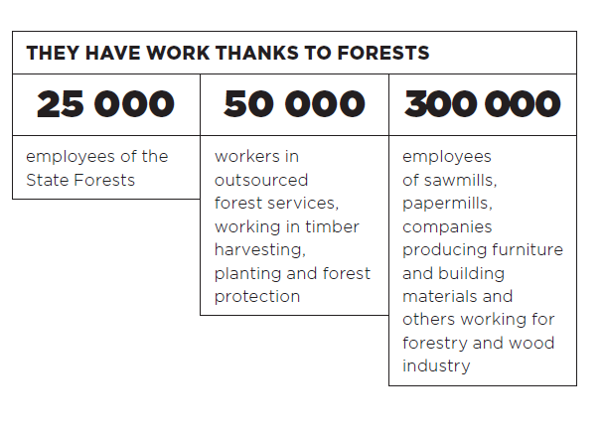

- Forest ownership
The ownership structure of forests in Poland is dominated by public forests – 80.8%, including forests managed by the State Forest Holding “State Forests” (PGL LP) – 77%. During the years 1990-2015, the share of ownership of private forests increased by 2.2 percentage points, reaching the current 19.2%. The share of the public ownership of forests decreased adequately (from 83.0% to 80.8%). The increase in the share of forests in national parks, from 1.3% in 1990 to 2.0% in 2015, was mainly due to the formation of six new parks in the described period.

Source: Central Statistical Office, Forestry, 2016.
- Forest research and education

- Forestry research
There are many research project conducted in Poland on forestry issues. Each of the institutions mentioned in the previous section has an extensive research portfolio. The most common research topics relate to climate change, biological conditions of forests, silviculture, forest protection, wood production, forestry economics.
Research commissioned by the Directorate General of the State Forests in 2015 was significant for the development of all areas of forestry. Most research was carried out at the Forest Research Institute. In total, 99 research projects were pursued in 2015 costing PLN 42 070,5 thousand provided by the forest fund.

