Guided Contents

1. Brief Country Profile
The content includes:
- Land area, population and other information you would like to share with 16+1
members;
(2) Location;
(3) Natural environment including mountains, rivers, lakes and so on.

Czech Republic
The Czech Republic is a strategically located landlocked country in Eastern Europe. It sits astride some of the oldest and most significant land routes in Europe. The Czech Republic occupied a total area of 78,866 km² (30,450 mi²). It shares boundaries with Poland, Slovakia, Austria, and Germany and has a total boundary length of 1,881 km (1,169 mi). The capital city of the Czech Republic, Prague, is located in the north central part of the country.
The population of Czech Republic in 2005 was estimated by the United Nations (UN) at 10,212,000, which placed it at number 78 in population among the 193 nations of the world. In 2005, approximately 14 % of the population was over 65 years of age, with another 15 % of the population under 15 years of age. There were 95 males for every 100 females in the country. According to the UN, the annual population rate of change for 2005–10 was expected to be -0.1 %, a rate the government viewed as too low. The country has one of the lowest fertility rates in the world. The projected population for the year 2025 was 10,217,000. The population density was 129 per km² (335 per mi²), with the most densely populated areas in North Bohemia, Central Bohemia, and in Moravia.
The UN estimated that 77 % of the population lived in urban areas in 2005, and that urban areas were growing at an annual rate of 0.05%—essentially a standstill. The capital city, Prague (Praha), had a population of 1,170,000 in that year. Other major cities and their estimated populations include Brno, 400,000; Ostrava, 331,448; and Plzeň (Pilsen), 175,049.
The topography of the Czech Republic consists of two main regions. Bohemia in the west is comprised of rolling plains, hills, and plateaus surrounded by low mountains. Moravia in the east is very hilly. The country's highest point is Mt. Sněžka at 1,602 m (5,256 ft) in the Krkonoše Mountains along the north central border with Poland. The Elbe River is the nation's longest with a distance of 1,165 km (724 mi); located in the northwest, it runs north into Germany.

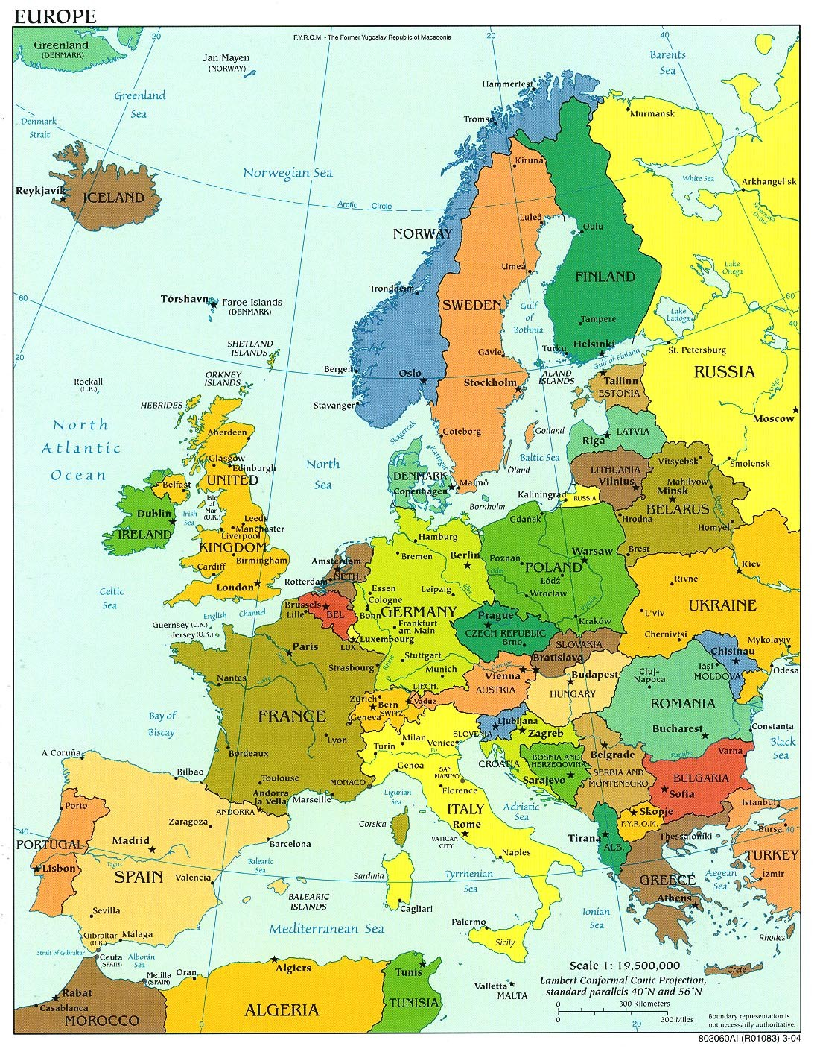
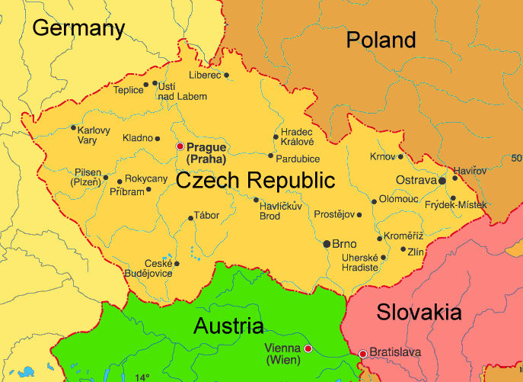

The Czech Republic has a Central European moderate and transitional climate, with variations resulting from the topography of the country. The climate is temperate with cool summers, and cold, cloudy, and humid winters. The average temperature in Prague ranges from about -1°c (30°f) in January to 19°c (66°f) in July. A generally moderate oceanic climate prevails in the Czech lands. Rainfall distribution is greatly influenced by westerly winds, and its variation is closely correlated to relief. Over three-fifths of the rain falls during the spring and summer, which is advantageous for agriculture. The precipitation range is from 50 cm (20 in) to more than 127 cm (50 in); rainfall is below 58 cm (23 in) in western Bohemia and southern Moravia.
Plants and animals are Central European in character. Almost 70 % of the forest is mixed or deciduous. Some original steppe grassland areas are still found in Moravia, but most of these lowlands are cultivated. Mammals commonly found in the Czech Republic include the fox, hare, hart, rabbit, deer and wild pig. A variety of birds inhabit the lowlands and valleys. Fish such as carp, pike, and trout appear in numerous rivers and ponds. As of 2002, there were at least 81 species of mammals, 205 species of birds, and over 1,900 species of plants throughout the country.
The Czech Republic suffers from air, water, and land pollution caused by industry, mining, and agriculture. Lung cancer is prevalent in areas with the highest air pollution levels. In the mid-1990s, the nation had the world's highest industrial carbon dioxide emissions, totaling 135.6 million metric tons per year, a per capita level of 13.04 metric tons. However, in 2000, total carbon dioxide emissions had decreased to about 118.8 million metric tons. Like the Slovak Republic, the Czech Republic has had its air contaminated by sulfur dioxide emissions resulting largely from the use of lignite as an energy source in the former Czechoslovakia, which had the highest level of sulfur dioxide emissions in Europe, and instituted a program to reduce pollution in the late 1980s. Western nations have offered $1 billion to spur environmental reforms, but the pressure to continue economic growth has postponed the push for environmental action.
The Czech Republic has a total of about 13 km³ of freshwater resources, of which 2 % is used for farming and 57 % is used for industry. Both urban and rural dwellers have access to safe drinking water. Airborne emissions in the form of acid rain, combined with air pollution from Poland and the former GDR, have destroyed much of the forest in the northern part of the former Czechoslovakia. Land erosion caused by agricultural and mining practices is also a significant problem.
In 2000, about 34 % of the total land area was forested. In 2003, about 16.1 % of the total land area was protected by the government. There are 11 Ramsar wetland sites in the country.
According to a 2006 report issued by the International Union for Conservation of Nature and Natural Resources (IUCN), threatened species included 6 types of mammals, 9 species of birds, 7 species of fish, 2 types of mollusks, 17 species of other invertebrates, and 4 species of plants. Endangered species include the Atlantic sturgeon, slender-billed curlew, and Spengler's freshwater mussel.
The Czech Republic is a classic example of a Central European country where the principles of sustainable forest management have been applied (naturally under the flag of sustainable yield) since the 18th century. Over the long term the Czech Republic has not experienced a loss in forest area, however, forest degradation has occurred. In fact, total forested area has continuously increased since the beginning of the last century, but unfortunately problems resulting from industrial air pollution still persist.
Czech forestry is mostly based on classical forestry, which originated in central Europe. In recent memory Czech forestry has been profoundly affected by the political system which arose after World War II. This system affected political life, but also forestry-related legislation and regulations, forest management, forestry research, extension and education. This political system had a negative impact on forest health, which in turn seriously weakened the ecological stability of forest ecosystems. As well, isolation and restrictions on foresters and forest scientists to outside knowledge and scientific contacts occurred.
Over the last decade, the economy of the Czech Republic has experienced a profound transformation and transition, going from one of central planning to a market-oriented approach. These changes have not only affected political structures, but also there have been economic and social spectrum effects. Today we face a new situation in which there are 145,000, private-sector forest owners. Small owners reassumed their proprietary rights to about 750,000 hectares of forests, but nearly 90 % of these owners possess on average less than 2 hectares of forest land, which is not favourable for forest management. The small owners, mostly heirs of the original owners, usually: i) have no idea on how to manage forests; ii) live in the town far away from their holdings; and iii) are already old and become the victims of dishonest, profit-seeking people who offer them services or want to purchase their forest holdings. Small holdings are not usually managed properly because the owners often lack the proper skills and knowledge and sometimes the owners have no interest in their holdings.
New forestry legislation has had to be adopted and a new system of maintenance and subsidies for private forest owners had to be put in place to promote sustainable forest management.
Return of forests to churches, still a political issue will mean that proper management practices will have to be carried out on about another 6 % of our forests. Also, afforestation of marginal agricultural lands is anticipated.

Map of altitudinal zones
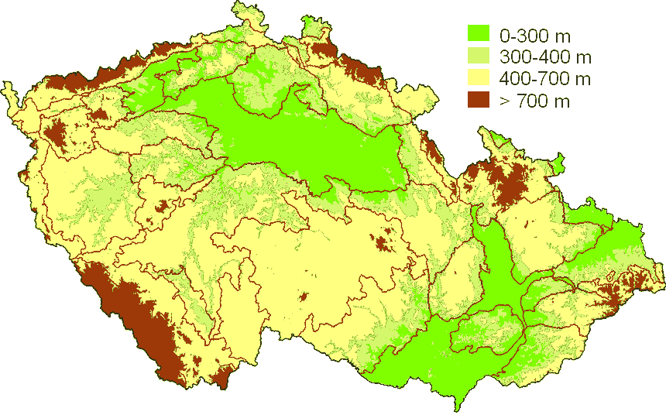

Map of Natural forestry reigions
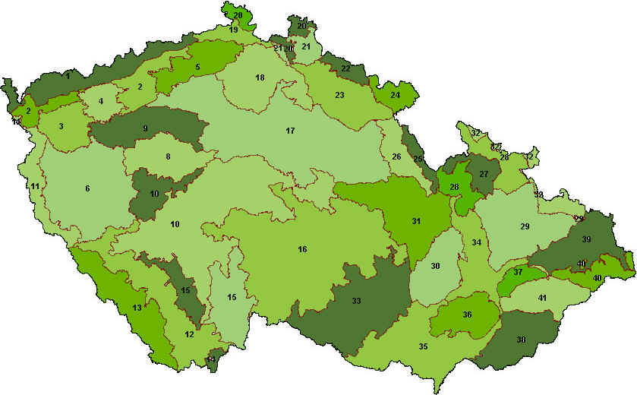

- Forestry and Forest
- Forest area
The area and change of the forest area in recent years
The total area of forest land in the Czech Republic has been constantly increasing. This is partly thanks to afforestation of new land, which exceeds the extent of transformation of forest land for other purposes, and partly thanks to the improvements as to the precision of data from the Land Register. In 2015, the forest land area increased in year-on year terms by 2 016 ha.
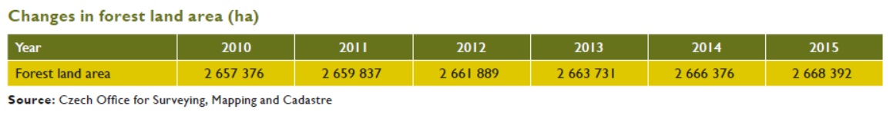

- Forest coverage and its change
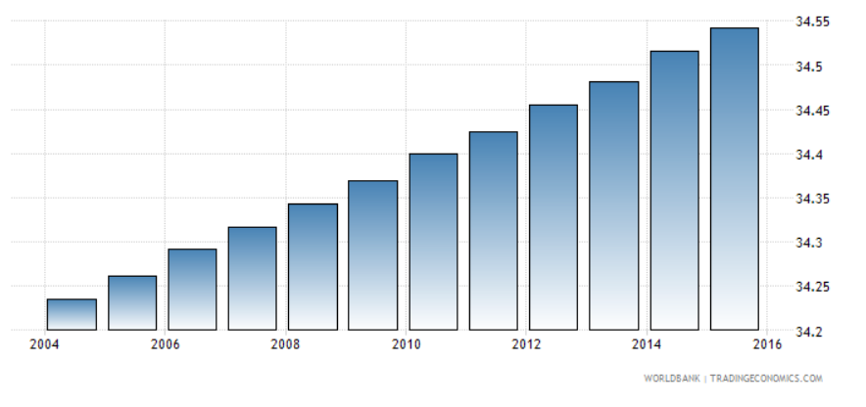
Forest coverage is still increasing in the Czech Republic.

- Forest classification
The area of each forest classification and its change Basis of classification
such as the primary forest, plantation.
Individual categories of forests are distinguished by their prevailing functions. A slight but persistent increment in the category of special purpose forests may be observed. Among other factors, this is caused by increasing demands of the society on non-wood forest functions. The total area of protection forests decreased again against 2014 by 11 887 ha. Taking into account the relatively stable natural conditions, it may be assumed that the existing potential to designate new protection forests is being utilised more efficiently.
Current state:
production forests – 1,938,797 ha
protection forests – 54,549 ha
special purpose forests – 611,283 ha

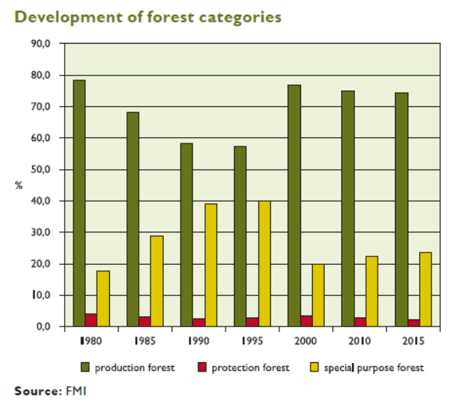

(4) Forestry structure
The basic situation of the tree species composition such as the area and
percentage for the main tree species;
The dynamic variation of the tree species in quantity.
The total area of main coniferous species, particurarly spruce, further declined. In contrast, the share of broadleaves, particularly beech, has been augmenting. When assessing the species biodiversity of national forests, the overall proportion of individual tree species is the major indicator, along with the distribution of forest stand mixtures within individual units of spatial arrangement of forests. The proportion between individual tree species within a unit has been continuously increasing in favour of mixed forest stands and forest stands with prevailing broadleaves, which was also the case in the year 2015. This increasing trend is a result of foresters' permanent efforts to acquire an optimum species composition of forests, a practice that enjoys a long-term support under a goal-oriented national subsidy policy.

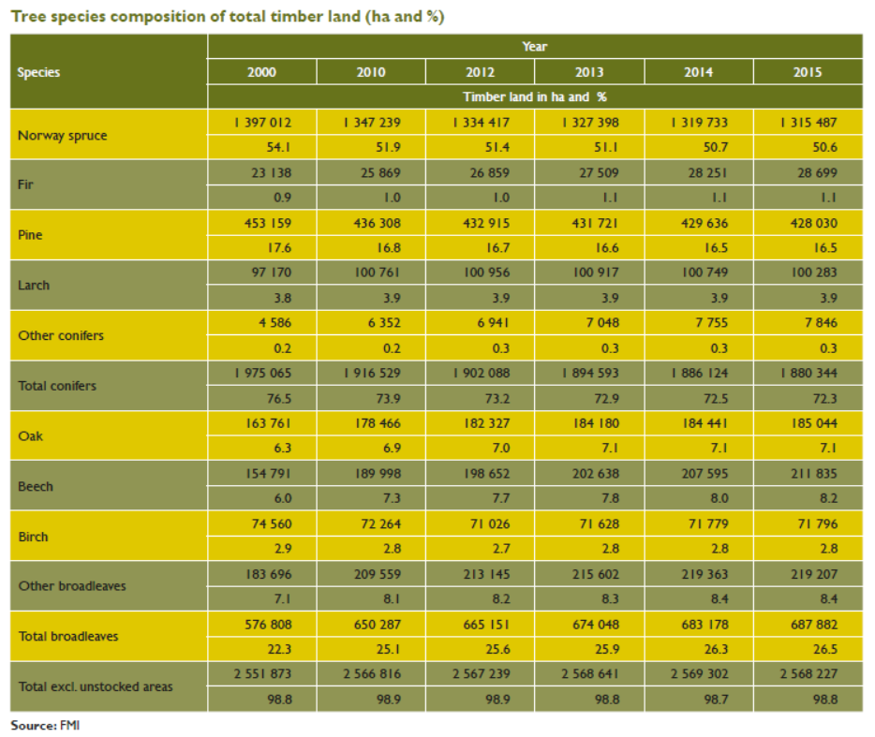

(5) Forest stock volume, increment and logging
The dynamic variation of the forest stock volume, increment and logging
Compared to 1930, the total growing stock in Czech forests more than doubled. The factors contributing to the fact are a higher increment and more precise determination using new methods and instruments implemented in the 60’s and 70’s of the 20th century. The total growing stock in Czech forests continued to extend also in the year 2015. This was thanks to a slight increase in stand stocking, an increase in the percentage of older stands. However, not all the stock is equally accessible for felling. The volume of felled timber in protection and special purpose forests is limited by fulfilment of protective functions or by special purpose management. In most cases, no felling operations may be carried out in forests with an increased protection regime, in nature reserves, and in first zones of national parks. The average growing stock per ha of forest land (i.e. growing stock on timber land including clear-cuts) is 259.6 m³.

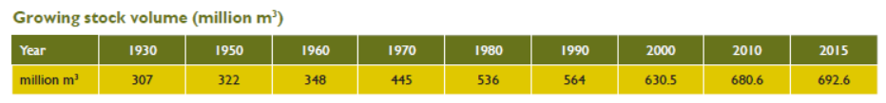
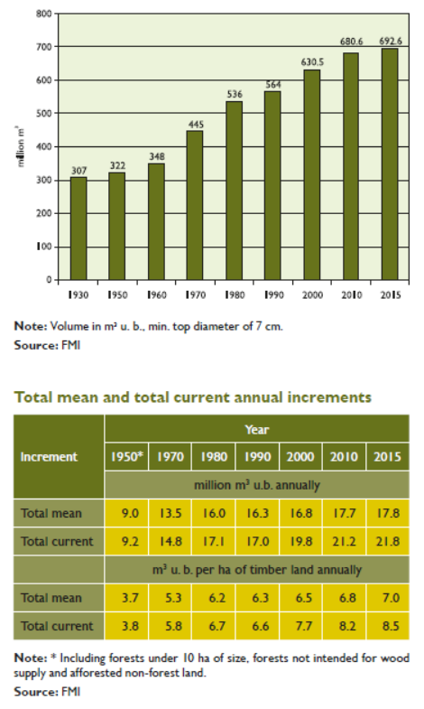

(6) Felling operation
The total volume of timber felled in recent 10 years;
The raw timber harvested in the Czech Republic in 2015 totalled 16.16 million m3 . Compared to 2014, this was 0.68 million m3 more. Salvage cutting substantially contributed to that volume with its share of 50.4% and totalled 8.2 million m³ , which rather worsened the conditions for forest management planning. Comparing the volumes of logged timber in individual species, the volume of harvested broadleaves stagnated, reaching approximately 11% of total felling. The proportion between harvested hardwood and softwood is mainly given by the demand on the timber market and by the structure of available reserves in mature stands.

Annual timber harvest
Harvest | Unit | 2000 | 2010 | 2012 | 2013 | 2014 | 2015
Conifers | Million m³ | 12.85 | 15.07 | 13.06 | 13.23 | 13.47 | 14-38
Broadleaves | Million m³ | 1.59 | 1.67 | 2.01 | 2.10 | 2.00 | 1-78
Total | Million m³ | 14.44 | 16.74 | 15.06 | 15.33 | 15.48 | 16-16
Per capita | M³ | 1.41 | 1.59 | 1.43 | 1.46 | 1.47 | 1-53
Per 1 ha of forest | M³ | 5.48 | 6.30 | 5.66 | 5.76 | 5.80 | 6-06

The planned felling volume in the next 10 years.
Not available

- Forest Management
- Institutions associated with forestry
Governmental organizations;
The central body that controls state administration in forestry is the Ministry of Agriculture. It revises the decisions made by the District Authorities and inspects their state administration in forestry. Currently Regional Authorities are created as the first level of state administrative organization.
The Ministry of Environment is the central body of state forest administration, game management and fisheries in the area of four National Parks covering a total area of approximately 120 000 hectares, which accounts for 1,5 % of the total surface of the Czech Republic. In addition to its responsibilities concerning National Parks, the Ministry of Environment has been enjoined by Forest Act (Act No.289/1995) with supreme state supervision of forest management in entire Czech Republic. The Ministry supervises how bodies of state administration, jurist and natural persons observe provisions of the Forest Act and related regulations. Carrying out of the duties of state supervision in forests, the Ministry co-operates with the Czech Environmental Inspection authority, which has a separate forest protection department, whose mission is to prevent and examine offences concerning the functioning of forests as an environmental component.
Forest Management Institute
Forest management began approximately 260 years ago and since that time offices of individual forest owners developed various management methods. The Forest Management Institute (FMI) was established in 1935. This institute refined forest management plans, executed real estates evaluation and land measuring and cartographic activities. Forest sites mapping started in 1941. Forest sites were characterised by forest communities, background for forest typology was established, and target species composition was defined for them. Forest management plans have been prepared and the systematic usage of computers was initiated in 1971. Thus, began the establishment of the information database. The institute was entrusted with creating a summary of forest management plans in five-year cycles. At the end of 1980s, employees of the institute developed a Czech GIS - TOPOLand mensurational programme.
After 1989 the FMI has been involved in the forest restitution process. In 1997, these duties and preparation of Forest Management Plans were transferred to private entities created mostly by former institute experts.
Nowadays the institute is responsible for executing forest inventory in the country, and elaboration and administration of Regional Plans of Forest Development (RPFD). Based on principles of sustainable forest management RPFD tries to minimise potential conflicts between the public and private owners` interests. These include the administration of information and data centres of forest management, execution of forest typological system, providing information services for forest certification. The National Certification Centre also provides support to organizations dealing with forest certification, e. g. the national governing body: PEFC (Pan European Forest Certification) Czech Republic). The FMI elaborates analyses, methodologies, layouts and prognosis and also is involved in domestic and international research projects as well as working in consultation activities.
Forestry and Game Management Research Institute
Previous to the political transition, research institutions were an integral part of the central planning system. Today state funding for forestry has steadily declined, and has not been supplemented from other sources. Numbers of personnel in forestry institutions have diminished due to decreased funding and lack of an appreciation for their results. Thus forest research has suffered and ongoing research tends to largely focus on classical scientific and technical topics that were in vogue during the previous era. As a result, research is not evolving to meet new social and economic needs emerging from ongoing privatisation. Forestry institutions, not only those doing research, are now facing competition from national and international sources and new forest owners, having many other problems, are not interested in funding research. Dwindling numbers of researchers are faced with increasing workloads. It seems that the worst problem is a lack of young people willing to do research under the current conditions.
In spite of problems FGMRI fulfils its main task of doing long term scientific research to improve forest management and ensuring that the results are put into forestry practice. Eighty years of forestry research was commemorated in 2001.
Conversely, the political changes have brought major benefits for forest research such as new possibilities for international contacts, participation in joint programs, exchange of information through personal contacts and access to the latest results and new technologies. Consequently, forestry researchers now have a better understanding of concepts and provide better tools for making sustainable forest management more profitable and acceptable.
As well, new opportunities have arisen such as the possibility to participate in the 6th Framework Program prepared by the EU.
Employees of the institutes mentioned above also fulfil follow-ups of the Ministerial Conferences on Protection of European Forests and other obligations resulted from international commitments.
Forests of the Czech Republic, State Enterprise
More than 1.4 million ha of the forest area are managed by the "Forests of the Czech Republic, state enterprise" (LCR), established in 1992. These forests contain a significant part of the former state forest property and include roughly 20,000 kilometres of streams. LCR is not bounded to the state budget and it fulfils the tax liabilities in the same way as any private subject. The new organization consists of 17 Regional Forest Districts, 87 Forest Districts (basic management unit), 6 Regional Administration of Streams, plus running a tree Seed Plant. Subcontractors (companies) carry out work on most of maintained forests. As a state company responsible for a significant share of activities in the public interest the LCR places major emphasis on the development of areas serving the public. The so called "Programme 2000" focuses on specific forestry-related functions activities and their completion.
Joint-stock companies, as private firms, are expected to offer the most recent skills when providing their services. Such companies are paid for their services, but they do not rent or own forest stands. They, together with other small business entities and companies, give a competitive environment to the forestry sector. Their work activities are done through contracts made with the LCR and the work must be done according to forest management plans for the corresponding area. A business contract is concluded for a specific period of time, usually two years and always for a specific area - so called contract area unit. The conditions for concluding this type of contract, which is confined to a specific ground unit and includes activities such as logging or silvicultural projects, is done via competitive bidding. The projects are processed and the Forest District pays for the finished work. The business contract includes the sale of lumber to companies on the "stump" site as well.
Besides the organizations mentioned above, many others are involved in forestry issues, both in the field of forestry and the environment. These include National Parks, Protected Landscape Areas Administrations, Nature and Landscape Protection Agency, Czech Ecological Institute, universities and schools with relevant orientation and professional associations (Association of Municipal and Private Forest Owners /SVOL/, Czech Forestry Society, Forestry Union, Czech Academy of Agricultural Sciences, and the Forest Nursery Association). NGOs, involved in forestry related issues, which should be mentioned, include the National Forest Committee, PRO SILVA Bohemica, and the Rainbow Movement. Most of them have been consulted during the preparation of the National Forest Programme.

Non-governmental organizations.
Not available

(2) Forestry employment
The number of employees in forestry;

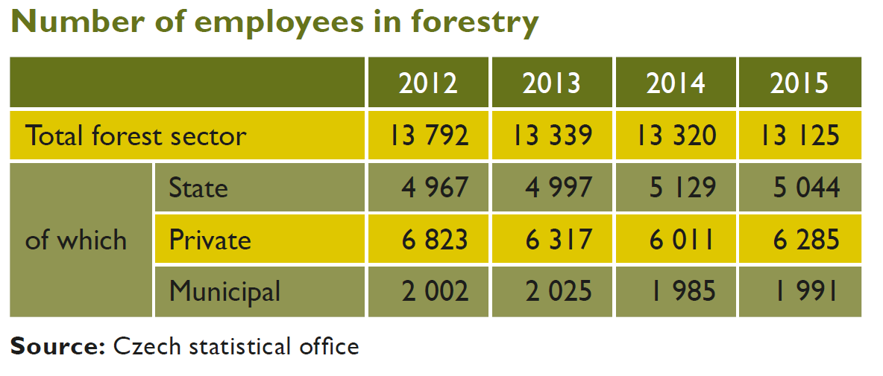
The dynamic variation of the number of employees in forestry.
Not available

(3) Forest ownership
The area and percentage of the forest ownership including private and sate owned and public forest;
The dynamic change in the proportion of the forest ownership.

Most forest land is owned by the state and is predominantly managed by Lesy České Republiky. Private entities and municipalities represent other major forest owners, while the remaining forms of ownership are rather marginal and statistically less signiﬁcant. More substantial modiﬁcations in the ownership structure are to come in the following years as a result of restitution of forest property to Churches.
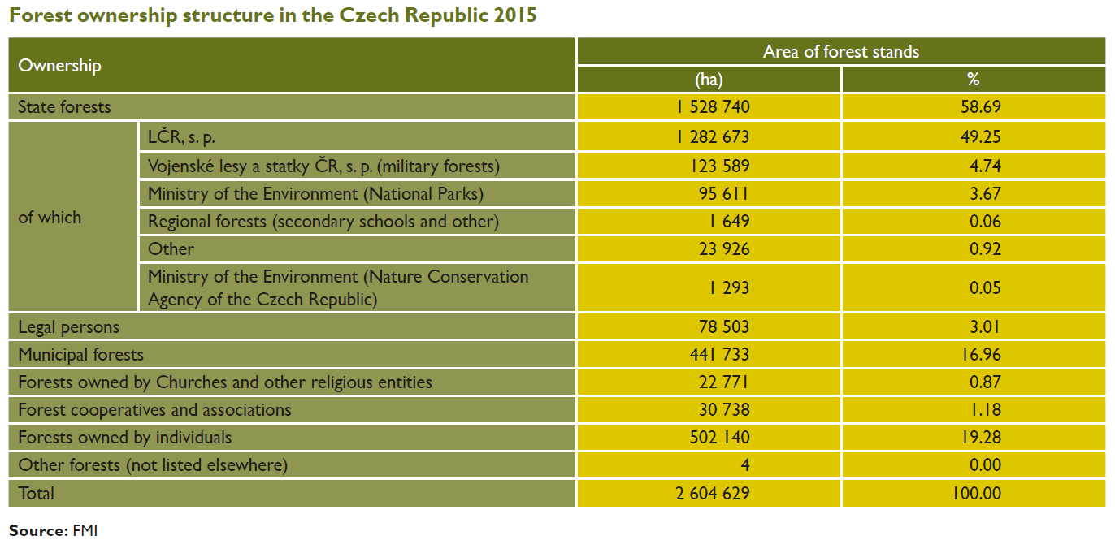
Privatisation of a small part of state forests is currently proposed as only a tool for integration of scattered holdings. A significant share of the state forests area is considered to be a stabilising factor, which will influence necessary improvements in air polluted areas, and timber market and social-economic relations in the country.

- Forestry policy
A brief description of the Forest-related policies and laws
Conception of forestry in the Czech Republic proceeds from the so-called Pan-European process initiated by the MCPFE. The idea of sustainable development, as interpreted in Helsinki 1993, includes the principle of sustainable forest management. Another source for the concept analysis is "The Basic Principles of the State Forest Policy", approved in May 1994. The amendment for "the pre-accession period to the EU" was adopted in 2000. Subsequent implementation of state forest policy targets is contained in the annual, state reports on Czech forestry.
Preservation of our forests for the future has become an ethical commitment of the present generation and the principal aim of current forest policy. The fact that forestry is a business activity and a part of an open, market oriented economy must also be recognised.

- Investigation and monitoring of forestry resources
National Forest Inventory (NFI) is an independent survey on the state and development of forests. The aim of NFI is to provide comprehensive data on the state of forests in the Czech Republic, both in terms of environmental sustainability and in terms of economic use. The Czech Republic was included among the European states that NFI carried out over several decades.
NFI is based on mathematical-statistical basis, which allows an objective and independent assessment of the actual state and development of forests in the Czech Republic.
The implementation of the National Forest Inventory is enshrined in Article 28 of the Act No. 289/1995 Coll., on forests and on amendments to certain Acts (the Forest Act). Implementation of the first cycle NFI was approved by the Government Regulation No. 193/2000 Coll., and second cycle by the Regulation No. 247/2009 Coll.
Year 2014 is the last year of the implementation of the second cycle of NFI ground investigation. The results of this inventory were published in 2015.
Results of the first cycle of the National Forest Inventory are available in Czech-English publication of the National Forest Inventory of the Czech Republic in 2001 Introduction, methods, results. The Forest Management Institute has own representative in the European National Forest Inventories Network – ENFIN.

4. Forestry Research and Education
- Forestry Research
Forest related institutions
Czech University of Life Sciences Prague - Faculty of Forestry and Wood Sciences
Mendel University in Brno - Faculty of Forestry and Wood Technology
Forestry and Game Management Research Institute

- Forestry Education
List of forestry universities
Czech University of Life Sciences Prague - Faculty of Forestry and Wood Sciences (FFWS)
Mendel University in Brno - Faculty of Forestry and Wood Technology (FFWT)

The forestry related majors in each forestry universities
FFWS
Accredited study programs and branches of study taught in the Czech language
Bachelor study program Forestry
Study specialization: Forestry; Economic Administration Services in Forestry; Operation and Game Management; Preservation of Products of Nature and Taxidermy

Bachelor study program: Wood Technology
Study specialization: Wood Technology; Business in the Wood Processing

Master study program: Forest Engineering; Wood Engineering

PhD study program: Forest Engineering
Study specialization: Forest Biology, Forest Management, Silviculture, Forest Protection and Game Management, Wood Processing and Machinery

PhD study program: Economics and Management
Study specialization: Economics and Management of an Enterprise

Accredited study programs and branches of study taught in the English language
Bachelor study program: Forestry
Study specialization: Forestry; Game Management

Master study program: Forest Engineering
Study specialization: Forest Engineering; Forestry, Water and Landscape Management; Tropical Forestry and Agroforestry

PhD study program: Forest Engineering
Study specialization: Forest Biology, Forest Management, Silviculture, Forest Protection and Game Management, Wood Processing and Machinery

PhD study program: Economics and Management
Study specialization: Economics and Management of an Enterprise

Number of forest-related students and the international students

FFWS
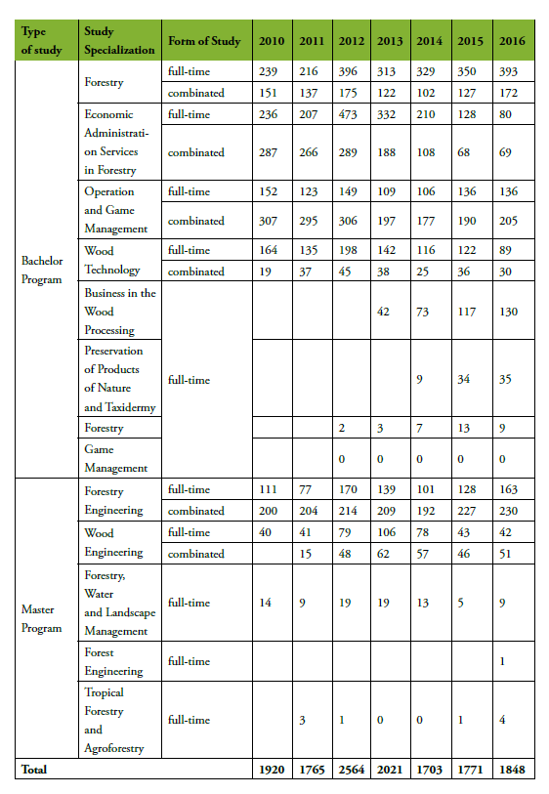
Number of students at FFWS (bachelor and master program)
Number of students at FFWS (PhD study program)


5. Forest economics
(1) Forest contribution to GDP
Gross added value of forestry, the country’s GDP and the share of forestry’s contribution;

In the year 2015, the Czech Republic recorded a year-on year growth in GDP by 4.3% at constant prices. The real GDP growth in the Czech Republic in 2015 was higher than both in the euro area1 (1.6%) and the entire EU 28 (1.9%). As stated by Eurostat, the Czech Republic reached 85% of the average GDP volume index per capita in the purchasing parity of the EU 28 in the year 2014.

(2) Forestry - related industrial chain
Yield and output value of wood and non-wood forest products
The Czech Republic showed an increase of over one million m3, largely as a result of one new mill processing up to 1.0 million³ m of sawlogs.
In spite of the fact that the collection of non-wood forest products (NWFPs) is a very popular activity, there was no objective information about the importance of NWFPs in the Czech Republic before the Grant Agency of the Czech Republic and the Czech Ministry of Agriculture (Forestry Branch) funded a large investigation on the socio-economic importance of NWFP collection, which was launched in 1994.
The total average yearly value of the collected NWFPs reached about 2,700 million CZK (CZK 1 = US$ 0.028) for the period 1994 to 1996. This is a surprisingly high value, equivalent to between one-fourth and one-third of the timber sold annually in Czech markets in recent years (which varied from CZK 9,000 million to CZK 12,000 million from almost 2.6 million ha of forests -one-third of the Czech Republic's area). The value of products collected from 1 ha of forest land reached on average CZK 1,100 yearly. The value of bilberries picked from 1 ha of a bilberry cover reached more than CZK 4,000, which is similar to the average value of timber extracted from 1 ha in an average year (CZK 4,000 to CZK 5,000). Bilberries cover almost 10 percent of total forest land in the Czech Republic.
The shadow net income for the population (based on the difference between market value and expenses) reached almost CZK 2,500 million per year. Shadow profits (the net of the cost of picking time and resulting forest damage) amounted to CZK 211 per hectare. By comparison, the profits from timber production were CZK 290 per hectare before taxes in 1995.
The figures given here do not overestimate the importance of forests and forestry as producers of NWFPs. Apart from the products discussed, people also collect and use free of charge other commodities on a large scale. For example, responses to the 1994 study indicated that 2.8 million kg (dry weight) of medicinal plants were collected, an important part of them in forests.

(3) Forest products import and export trade
Import volume, import value, export volume, export value for all woor and non-wood forest products since 2010 (or 2000)

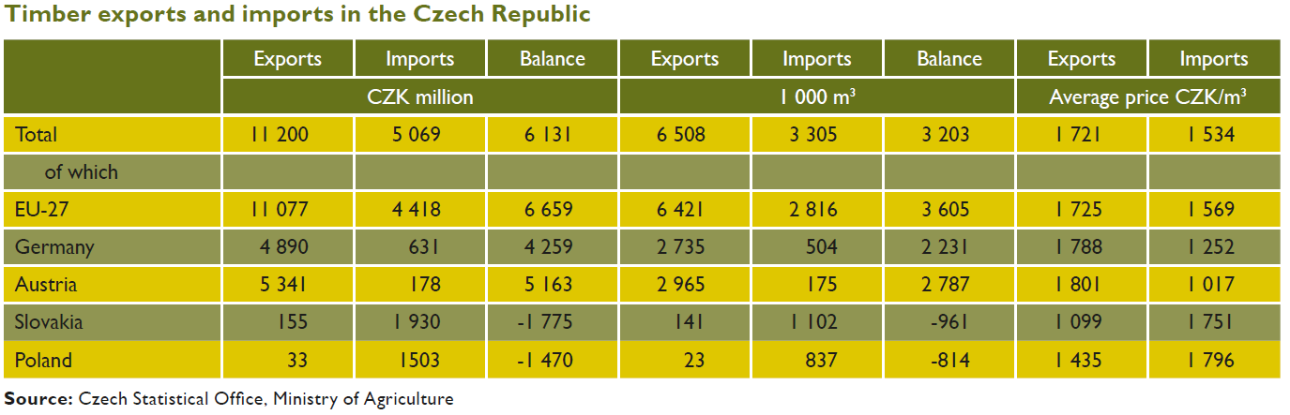
Import and export values of forest products in Czech Republic in the year 2015 are presented in the tables below.

